Motorist Driving Offenses
Penalty Points
Management System

Student Name Student No
Anthony O’Toole x11106697

Ronan Leonard x11106611

Claire Collins x11106425

Table of Contents
Project Scope 2
Project Requirements 2
Technical Environment 2
Core Functional Requirements 2
Design Criteria 2
Initial Database Table Normalisation 3
Motorist Offences processing Life Cycle 4
Proposed Main User Hierarchy 5

Project Scope
- The scope of this project will be heavily impacted by the steep learning curve required to implement said project as an Enterprise Framework solution.
- Consequently, the project scope is very likely to shrink and certain Design Criteria Functional Requirements may not be met in the given time frame. So the scope of this project is, at present, aspirational.

Project Requirements
- Html(JavaScript) UI Front End
- C# Middle Ware
- Database Backend
- Restful approach
- Mash-up (use of External SOA/API )
- Make aspects of the project into a SOA/API for external use

Technical Environment
- Visual Studio Professional 2010 IDE
- ASP.NET MVC3
- Entity Framework version 4
- SQL Server Express 2008

Core Functional Requirements
- Methods of adding points to a motorists record
- Method to notify a motorist of their offence
- Method whereby a daily check of all non-responders to our 21 day limit can be summonsed of court proceedings
- Method to notify motorist of a 6 month ban from driving if they accrue 12 or more points within a 3 year period.
- Drivers’ penalty points stay on their licence for 3 years (irrespective of a 12 point driving ban). We need a method to remove points 3 years old or more – this would take the form of a daily check.
- Method to allow a 3rd party (Insurance Company) access the accrued points tally (only!) of a particular driver based on the drivers licence number.
- Create three users :-
  - one a DBA (garda1) and the other two as follows
  - one a normal user (garda2) with resource permissions to use the DB
  - one a guest (garda3) who can only view data
  - create two roles, each with appropriate privileges, for the two (non-DBA) users
- Allow a 3rd party (Insurance Company) access the accrued points tally (only!) of a particular driver based on the drivers licence number.

Design Criteria

- Use of Database (Normalisation) & application level Object Oriented design principles?
- To be verified with Adrian Skehill.

Initial Database Table Normalisation

Entity/Attributes, Foreign Keys & Referential Integrity (3rd Normal form)

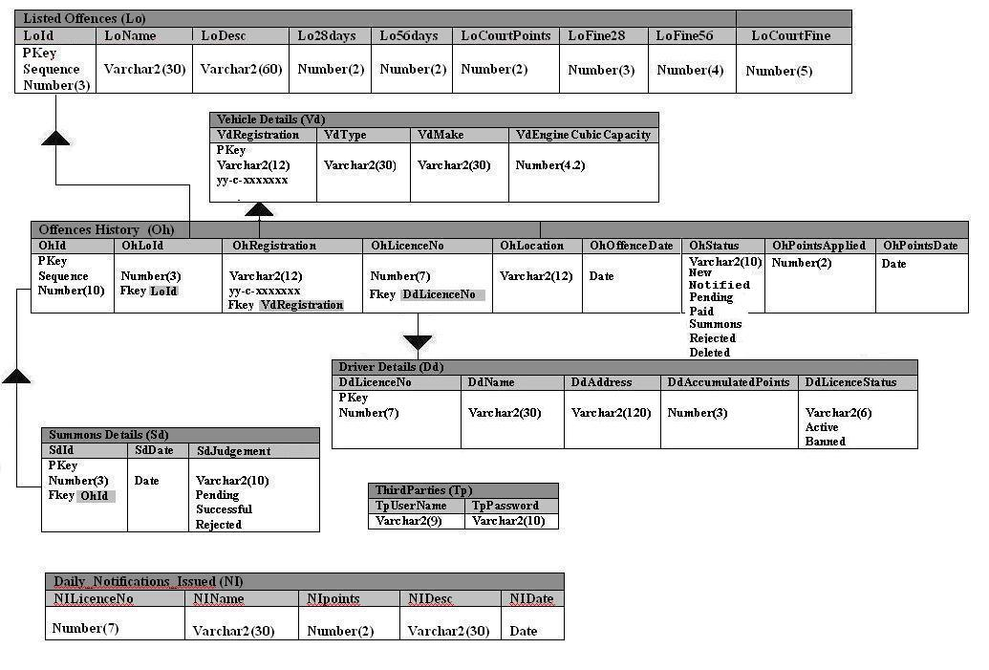

Motorist Offences processing Life Cycle
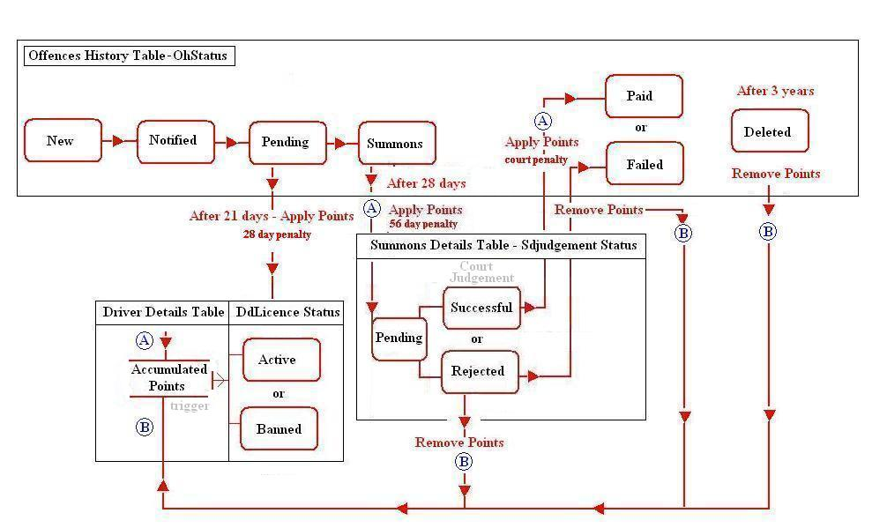

Proposed Main User Hierarchy
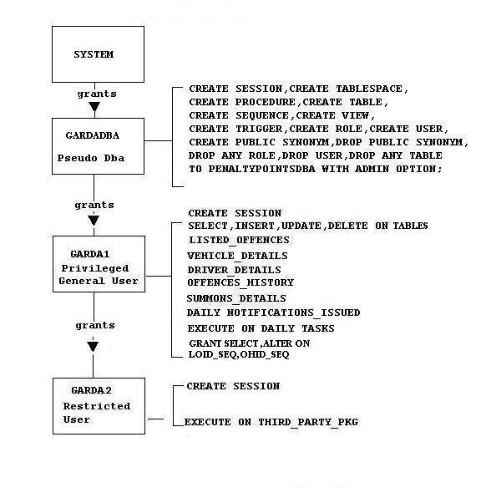
Other 3rd Party Users - Insurance Companies

